**Design for class “Order”**

Figure 1: Design Class of Order

Table 1: Attribute design of Order

|  |  |  |  |  |
| --- | --- | --- | --- | --- |
|  | **Name** | **Data Type** | **Default value** | **Description** |
| 1 | orderID | int | N/A | Unique identifier for the order |
| 2 | invoiceID | int | N/A | The corresponding invoice |
| 3 | productList | Map<Product, int> | N/A | A list of media items associated with the order |
| 4 | isRushOrder | boolean | N/A | A flag indicating whether the order is a rush order (true or false) |
| 5 | orderStatus | char | N/A | Status of the order |
| 6 | deliveryInfoID | intr | N/A | The corresponding delivery information ID |
| 7 | paymentTransactionID | int | N/A | The transaction ID used for refunds, if applicable |
| 8 | orderDate | date | N/A | The date when the order was placed |
| 9 | totalPrice | int |  |  |
| 10 | totalItems | int |  |  |
| 11 | curency | String |  |  |
| 12 | refundTransactionID | Id |  |  |
| 13 | rejectionReason | String |  |  |

Table 2: Operation design of Order

|  |  |  |  |
| --- | --- | --- | --- |
|  | **Name** | **Return Type** | **Description** |
| 1 | updateRejectedStatusandReason () | void | Update the status of order to Rejected |
| 2 | updateRefundStatus () | void | Update the status of order to Refund |
| 3 | getter() | void | Controllers get the information to create Invoice |

1. updateRejectedStatusandReason ()

**Parameter**

|  |  |  |
| --- | --- | --- |
| **Name** | **Default Value** | **Description** |
| Reason |  |  |

**Method**

|  |
| --- |
| public void updateRejectedStatusAndReason(int reason) {  this.status = "rejected";  this.rejectionReason = reason;  } |

1. updateRefundStatus ()

|  |  |  |
| --- | --- | --- |
| **Name** | **Default Value** | **Description** |
| refundTransactionID |  | The payment transaction ID |

**Method**

|  |
| --- |
| public void updateRefundStatus(String refundTransactionID) {  this.status = "refunded";  this.refundTransactionID = refundTransactionID;  } |

**State Diagram of order**

**Design for class “RejectOrderController”**

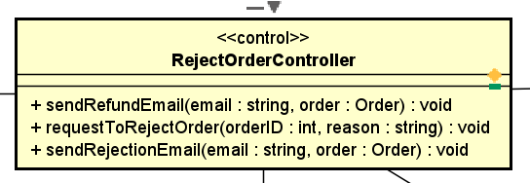

Figure 2: Design Class of RejectOrderController

Table 3: Operation design of RejectOrderController

|  |  |  |  |
| --- | --- | --- | --- |
|  | **Name** | **Return Type** | **Description** |
| 1 | sendRefundEmail () | void | User submit the information |
| 2 | requestToRejectOrder() | void | Display the delivery information form |
| 3 | sendRejectionEmail () | void |  |

1. sendRefundEmail ()

**Parameter**

|  |  |  |
| --- | --- | --- |
| **Name** | **Default Value** | **Description** |
| email |  |  |
| order |  |  |

1. sendRejectionEmail

**Parameter**

|  |  |  |
| --- | --- | --- |
| **Name** | **Default Value** | **Description** |
| email |  |  |
| order |  |  |

1. requestToRejectOrder()

**Parameter**

|  |  |  |
| --- | --- | --- |
| **Name** | **Default Value** | **Description** |
| orderID |  |  |
| reason |  |  |

**Exception**

|  |  |
| --- | --- |
| **Name** | **Description** |
| InvalidRejectionReasonException |  |
| OrderNotFoundException | If orderID is not valid |

**Method**

|  |
| --- |
| public void requestToRejectOrder(String reason, int orderID) throws InvalidRejectionReasonException, OrderNotFoundException {  if (reason == null || reason.isEmpty()) {  throw new InvalidRejectionReasonException("Rejection reason cannot be empty.");  } else {  Order order = Order.get(orderID);  if (order == null) {  throw new OrderNotFoundException("Order with ID " + orderID + " not found.");  }  order.updateRejectedStatusandReason(reason);  }  } |

**Design for class “RefundTransaction”**

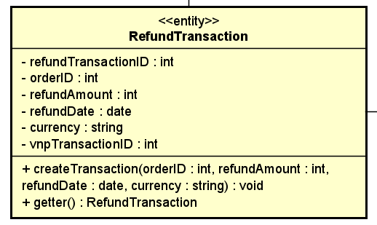

Figure 3: Design Class of RefundTransaction

Table 4: Attribute design of RefundTransaction

|  |  |  |  |  |
| --- | --- | --- | --- | --- |
|  | **Name** | **Data Type** | **Default value** | **Description** |
| 1 | refundTransactionID | int | N/A | Unique identifier |
| 2 | orderID | int | N/A | The corresponding order |
| 3 | refundAmount | int | N/A |  |
| 4 | refundDate | date | N/A |  |
| 5 | currency | string | N/A |  |
| 6 | vnpTransactionID | int | N/A | The transaction information from VNPay |

Table 5: Operation design of RefundTransaction

|  |  |  |  |
| --- | --- | --- | --- |
|  | **Name** | **Return Type** | **Description** |
| 1 | createTransaction () | RefundTransaction | Update the status of order to Rejected |
| 2 | getter () | void | Update the status of order to Refund |

1. createTransaction ()

**Parameter**

|  |  |  |
| --- | --- | --- |
| **Name** | **Default Value** | **Description** |
| orderID |  |  |
| refundAmount |  |  |
| refundDate | date | N/A |
| currency | string | N/A |
| vnpTransactionID | int |  |

**Exception**

|  |  |
| --- | --- |
| **Name** | **Description** |
| OrderAlreadyRefundedException | If Order is already refunded |
| OrderNotFoundException | If orderID is not valid |

**Method**

|  |
| --- |
| public void createTransaction(int orderID, int refundAmount, Date refundDate, String currency)  throws OrderAlreadyRefundedException, OrderNotFoundException {  if (order.getOrderID() != orderID) {  throw new OrderNotFoundException("Order with ID " + orderID + " not found.");  }  if (order.isRefunded()) {  throw new OrderAlreadyRefundedException("Order with ID " + orderID + " has already been refunded.");  }  RefundTransaction transaction = new RefundTransaction(orderID, refundAmount, refundDate, currency);    } |

**Design for class “PendingOrderScreen”**

Figure 4: Design Class of PendingOrderScreen

Table 6: Operation design of PendingOrderScreen

|  |  |  |  |
| --- | --- | --- | --- |
|  | **Name** | **Return Type** | **Description** |
| 1 | requestToRejectOrder () | void |  |

**Design for class “PaymentGateway”**

Figure 5: Design Class of InvoiceScreen

Table 7: Operation design of InvoiceScreen

|  |  |  |  |
| --- | --- | --- | --- |
|  | **Name** | **Return Type** | **Description** |
| 1 | refund () | void | Request VNPay to refund the corresponding order |

**Parameter**

|  |  |  |
| --- | --- | --- |
| **Name** | **Default Value** | **Description** |
| paymentTransaction |  |  |